Object Detection Using Python
In this project using python, yolov3 (You Only Look Once v3) and OpenCV algorithms we are detecting objects from video and images. Yolov3 is a famous object detection algorithm developed by Washington university, this algorithm generate yolov3 weight model using python Deep Learning algorithm called CNN (Convolution Neural Networks). This algorithm is pre-trained with all images and assign unique class name to each unique images and then generate a model, this algorithm convert each images into layers and then for each layer extract features and add weight to the model, due to all possible features from single image another image with some related features can also be predicted. Whenever we are giving new image then that image will be applied on pre-trained weight model to get best accuracy matching image label.
You are asking to detect object without using any pre-trained model and it is highly impossible as all Deep Learning CNN networks works by using pre-trained models only.
To run this project you need to use below commands
python yolo.py image images/test.jpg
In above command python is the software name and yolo.py is the program name and ‘image’ means we want application to detect object from image and ‘images/test.jpg’ is the input image. Similarly for videos instead of image we need to pass video with video path.
python yolo.py video images/video5.mp4
When we are giving video then it will take time to extract all frames from video for object detection and then create a new video called ‘newvideo.avi’ in the same code folder. If it’s taking long time then you can press CTRL+C to stop execution and then you can play ‘newvideo.avi’ file.
Screen shots
For testing I am using below image
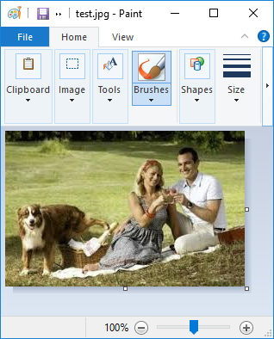
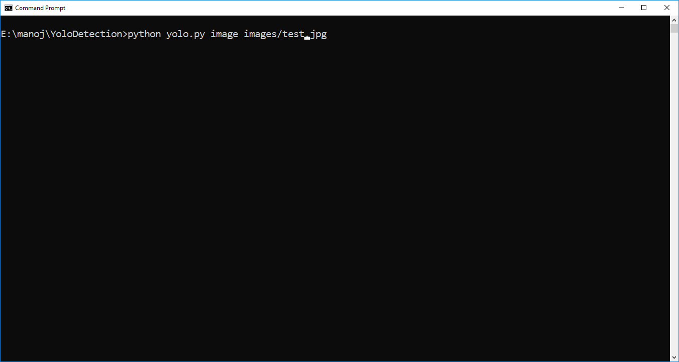
Using above command running yolo from image, after running above command will get below screen
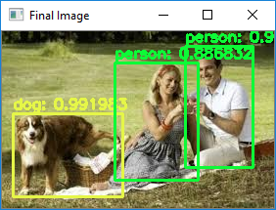
Use below screen command to run with video
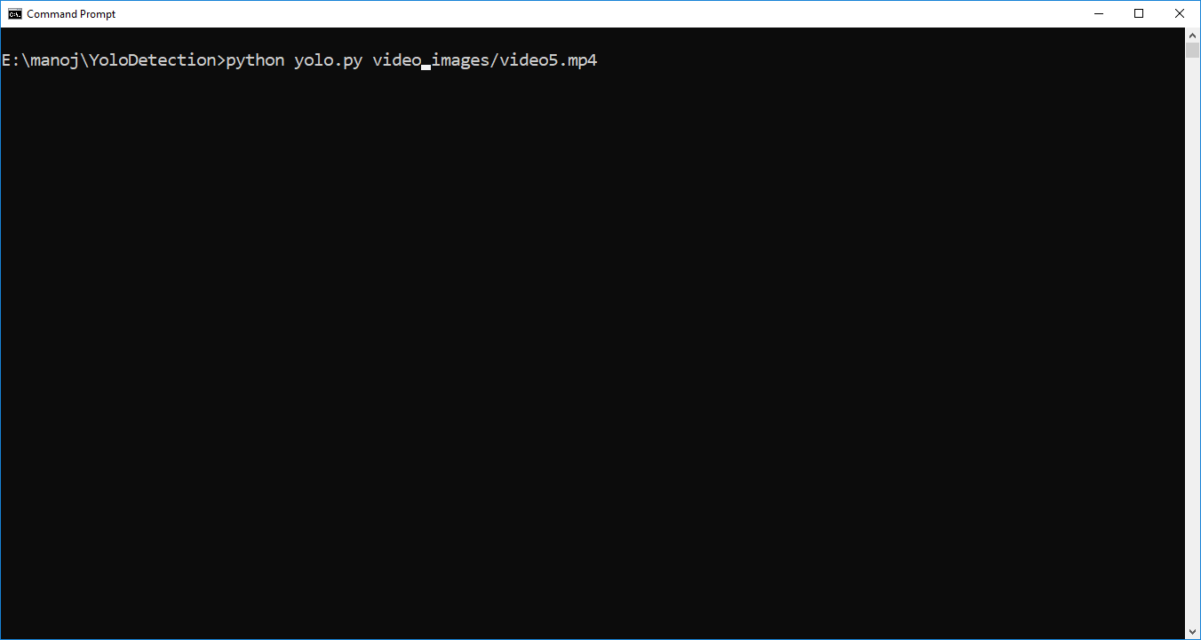
After running above command it will start generating new video when we play will get below screen
